Seven Golden Use Cases
From design to code

Seven Golden Use Cases 1
Take a top-level view 1
Top Level Use Cases 3
Burrow Down 3
Sample Use Case Description 7
Where is the Functionality? 8

Seven Golden Use Cases
This may seem quite shocking (and I am sure there are some system analysts that might be appalled by this idea) but every system on the planet only ever does seven things in my view.
They are…
- Add create a new unit of data in the system
- Edit update an existing unit of data
- Delete remove a unit of data
- List provide a list
- Find find a single item
- Filter filter the list passed on some sort of pattern matching
- Validate check that data entering the system is correct
There are clearly other use cases but, in my view, they are merely variations on the above.
As programmers, once we realise this the whole process has the potential to become so much simpler.

Take a top-level view
Consider the following ERD for the widget system…
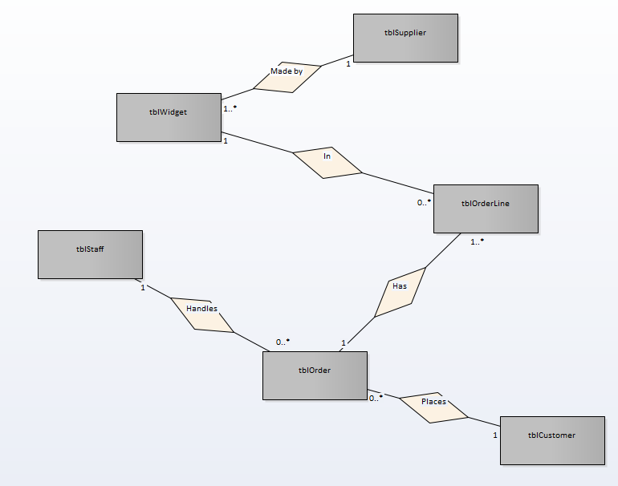
Note, there is no point creating an individual ERD, this needs to be a team effort to make it worthwhile.
Once we have the ERD we can identify the sub systems that make up the larger application…
- Stock Management tblWidget
- Supplier Management tblSupplier
- Staff Management tblStaff
- Order Management tblOrder – tblOrderLine
- Customer management tblCustomer
Clear this is incomplete – there are still sub systems that could be added to the design, the following sprint to mind
- Security may not appear on the ERD but likely part of the class diagram
- Shopping cart same as security – likely not part of the ERD
- Stock Purchasing probably should be on the ERD but also raises the issue of Purchase Order and Purchase Order Line

Top Level Use Cases
Once we have identified the sub systems in the wider application it might be a good idea to look at the system as a set of top-level use cases like so…
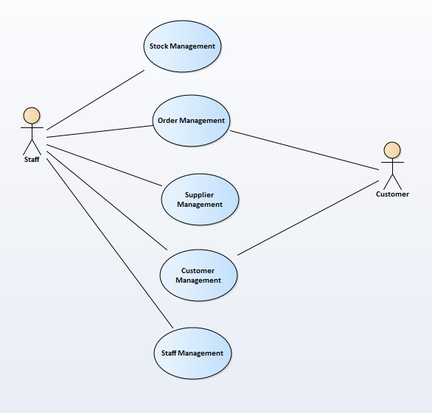

(Clearly this is incomplete, but it makes the point.)

Burrow Down
Having identified the top-level view, we are in a position to look at each subsystem in more detail, for example the first stab at the staff management system might look like this…
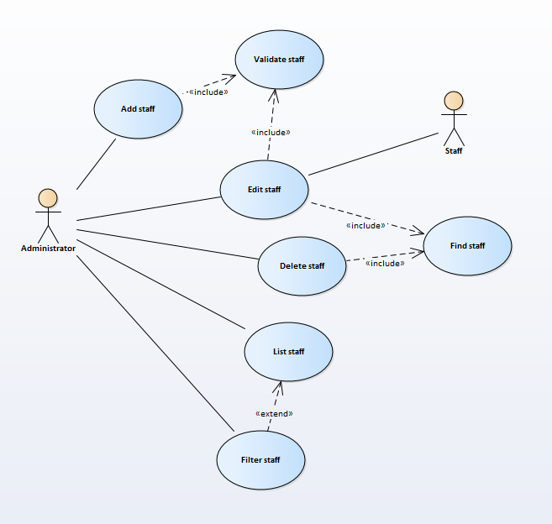
And here we have it the big seven use cases!
There will always by issues to consider at this point though, for example what do we do with delete?
Deleting records in a system is always a big deal. If a record has just been created and we realise it was done in error, then there is potentially a case for delete.
There are two other issues though…
- What happens to the relationships between records if we do delete a record between related tables with posted primary and foreign keys? This has the potential to break the integrity of the database.
- What happens if by law we are required to keep certain data e.g. records of previous employees?
- What happens if by law we must delete some data e.g. the details of customers who no longer wish to be part of the system?
Perhaps the addition of the following use cases could handle these scenarios…
- Archive Flag a record as inactive so it doesn’t come up in the main reports?
- Unarchive If we can archive records, we need a mechanism to bring the data back
- Anonymise Delete important data without deleting the record such that the individual can no longer be identified
The issues here are not necessarily trivial, what if there is data in related tables that combined could identify the personal details of the customer?
Perhaps we could modify the diagram like so…
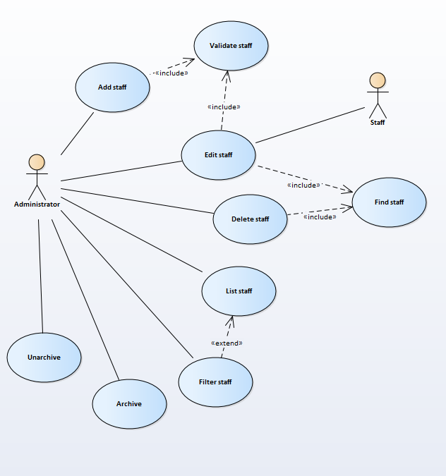
We are now able to create the use case descriptions for the use cases on the diagram.

Sample Use Case Description
The use case descriptions allow us to think more deeply about what is going on with a single use case
For example, the use case description for list staff might look like this.
Use Case Name (Short two- or three-word name) | List Staff
Use Case Description (Short description) | The administrator views a list of staff in the system
Use Case Author(s) (Who wrote this) | Rod
Actor(s) (Who does this) | Administrator
Locations (Where does this happen) | Part of the back-end functionality
Primary pathway (What is the normal “happy path” for this use case?) | List staff  User enters the system  A list is displayed to the user at system start
Alternate pathways (What other paths are there that are not the “happy path”?) | There is no data in the system – a message is displayed saying so  User applies filter  A filtered list is displayed to the user  User clears filter  Full list is displayed to the user
Exception pathways (What could possibly go wrong?) | Database connection fails  Error displayed to the user advising of connection problem

This is only one use-case. Each bubble on your diagram needs its own description.

Where is the Functionality?
Once we have a good idea of the use cases for the sub system we now need to think about where the code needs to go that makes the use cases work. This functionality needs to be described within the class diagram…
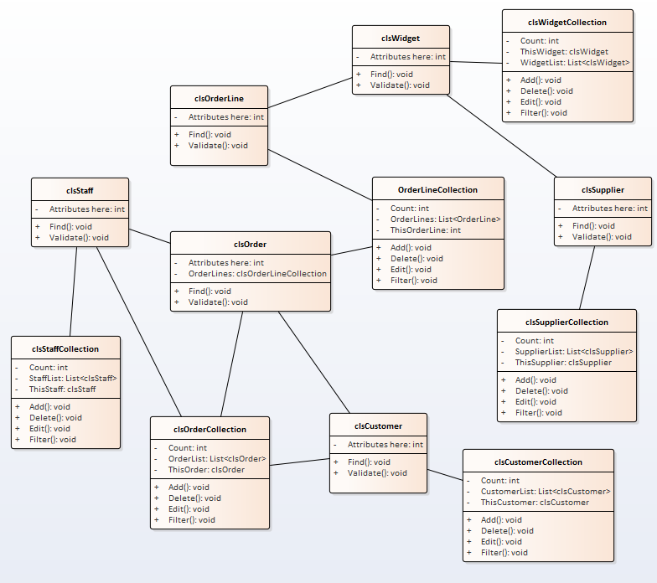
Like the ERD there is zero point creating an individual class diagram as there won’t be enough content to make it worthwhile.
This design has issues, mostly based on the features we are deciding to ignore namely…
- clsDataConnection ignore it. Its inclusion creates associations we don’t care about
- Inheritance this would remove a lot of duplication
- Composition & Aggregation this would allow us to express more nuanced detail
Yes, the diagram is simplistic and a bit rough and ready, but the point is that we can start writing the code for the system using a basic strategy of Test-Driven Development.

